Dementia Prediction Rate Using Linear Regression and DBSCAN Algorithm

William
Faculty of Engineering and Informatics Universitas Multimedia Nusantara,
Tangerang, Indonesia
william13@student.umn.ac.id

Abstract — In the Industry 4.0 era, data has a crucial role in technological development, for example in the health industry. We can use the data analysis method to processing data into useful information that can be the main basis for decision making to solving the health problem and health-tools development. The research object is the society that is divided into certain groups, such as socioeconomic status, age, years of education, and gender. In this paper, the researcher will compare the Linear Regression Algorithm and DBSCAN Algorithm using Dementia Dataset. The result of this research study is expected to be an education for the public about the main factors that cause dementia so the people can be more aware and prevent the main factors that can cause dementia.
Index Terms — DBSCAN Algorithm, Linear Regression Algorithm, Dementia, Age, CDR, Socioeconomic Status, Education

Introduction
Dementia is a common disease that usually attacks elder people and caused by several damages to nerve cells in the brain, which can occur in several areas of the brain. Dementia can appear in several forms in each patient, depending on the area of the brain that is affected [1]. One of the main symptoms of dementia is memory loss and hard to communicate because the brain can’t work optimally to be the center of the human body’s control. This nervous system works together with the peripheral nervous system to give humans the ability to do normal activities, such as walking, talking breathing, eating, and drinking. Some diseases that attack the human motor system (especially in the brain) have a similar symptoms as dementia, such as stroke and alzheimer’s that make the patient lose the ability to carry out simple activites, such as walking and ability to remember things [3].
Dementia is often misinterpreted as a senile disease. The fact is, they are different. A weak memory is not a reason that the person has dementia, it can be a normal aging process. Therefore, it is important to remember that dementia is not a normal part of aging. It is true that elderly person will have a higher chance to experience it, but it doesn’t mean that the younger generation can have this disease. It is estimated that there are 200 thousand people under the age of 65 who have dementia. Overall, there are 55 million people who have dementia where about 60% of them live in middle-to low-income countries. This number is estimated to increase into 78 million people that have dementia in 2030 and increase into 139 people in 2050 as the human population increases [4].
According to World Health Organization, most types of dementia cannot be cured at this time. However, the doctor that handles dementia patients will provide and assist the patient in managing the existing symptoms to slow and minimize the impact of symptoms. In certain cases, doctors may prescribe some medicine to treat the sleep disorders for patients and therapies that help the patients to adapt to living with dementia [2]. Some symptoms of dementia and behavioral problems can initially be treated with non-drug approaches, such as environmental modification, extra support, and modify the patients repsonse to learning the behavior.
Although it is quite difficult to treat and prevent dementia especially for elder people, there are several factors that have been proven to reduce dementia. Most of them are physical ability to train the brain to keep working, by being physically active through activities or simple game that stimulate the brain, such as puzzle and word games, it would train your memory and will help to reduce the appearance of dementia. Besides that, a healthy lifestyle can also help us to reduce the risk of developing dementia. By maintaining a healthy lifestyle of course our human body will be stronger and less frequent disturbances in the body. Some studies show that smoking in middle age can increase the risk of dementia and vascular disease. We can conclude that quitting smoke can reduce the risk to get dementia [5].
This research will be focused in the accuracy test from DBSCAN and Linear Regression algorithm to consider which algorithm is more accurate and suitable to help educate the society about the main factors of dementia so the people can be more aware and prevent the dementia in real-life situation.

Literature review

Definition of Linear Regression Algorithm
Linear Regression Algorithm is one of the data analysis algorithm methods that uses to check the relationship and the infulence between 2 or more variables quantitatively. The results of this algorithms are usually used as the reference to draw the conclusons whether there is a correlation between variables or not [5]. This method is often used to predict values that will occur in the future, such as stock price movement. This definition is directly proportional to the function of regression analysis which is intended for forecasting and prediction [6].
Linear Regression Algorithm is suitable to use when you are looking for the relationship between the independent and dependent variables[7]. When tere is a linear relationship betweem the two variables, ths algorithm is te most suitable algorithm to use. With this algorithm, we can check the multicolinearitu of the data, auto correlatiom, and also the distribution of the data whether the distribution occurs normally or not [8].
We have to analyze the linear model that we want to compare and we can use some testing methods[9]. These test such as Durbin-Watson test to check the auto correlation in data, and the second test is Anderson Darling to check whether the distribution occurs normally or not, and the third test is Variance Inflation factiors to check wheter there is multicolinearity or not . in this test, there are conditions that must be required, that at least 2 predictor variables in the linear model and the last test is the RMSE test to shows the prediction error[10].
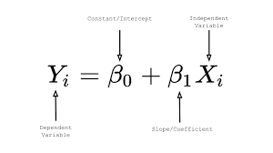
Image 1. Simple Linear Regression Formula

In the formula above, we use x as an independent variable and Y as Dependent Variable followed by the coefficient and the resulting intercept.

Definition of DBSCAN Algorithm

DBSCAN (Density-Based Spatial Clustering of Applications with Noise) is one of the algorithms thas used for clustering based on density in data analysis. This Algorithms usually applied to small-case dimensional data and used to make clustering based on density in data analysis. DBSCAN will separate the clusters in the datasets based on the density levels, whether its high density clusters or low density clusters. [11].
DBSCAN use 2 main paramateres to impelement the clustering methods, that is Epsilon and minimum points. Epsilon are use to show the minimum distance between 2 different data in one cluster, while the minimum points describe the minimum amount of data in epsilon [12]. The minimum point can be determined freely and every point that has neighbouring points more than the previously determined minimum points, then the point are included in the "core point", while the points that have neighboring points are smaller than the specified minimum points are included in the "border points". Besides that, there are also points that do not have neighborhood points which are usually called "Noise” [13].

Methodology

Research Objects
This paper uses data about people from different background in many variables, such as age, Socioeconomic Status, year of education, gender, and other medical components such as CDR rating and normalized whole brain volume. All of the data objects are right handed, both male and female gender.

Data Collection
This research use the datasest that can be accessed in one of the website that provide many datasets, kaggle.com. researcher have ensured that the dataset that used in this research doesn’t have empty data and its in accordance with the portion of each variable. This dataset includes quantitative data because the data can be expressed in numbers and can be measured in size (CDR Rate).
This dataset has 12 variables and 436 rows, where the majority of the variables are numerical data and valid to use in this dementia prediction topic.

Framework

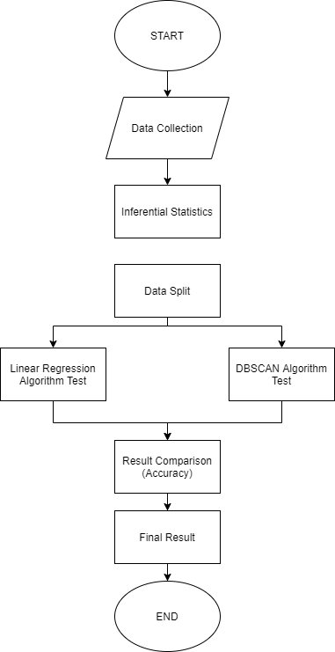

Image 2 Framework Diagram

Identification
In this process, we used the dataset in the form of csv, and we will use R Studio to read and classify the data. Researchers have to install the packages required to use Linear Regression and DBSCAN Algorithm such as nortest, lmtest, ggplot2, GGally, knitr, fpc, and rstatix packages.
The variables included in the dataset mostly are numerical variables, such as Age, Socioeconomic Status, years of education, and many variables that containt medical information (Brain-Volume, Mental State Examination, CDR rate, and Intracranial Volume). Categorical variables such as gender and Handedness do not significantly impact the comparison results because the majority of the dataset used is quantitative data. Numeric data will be used to splitting data and testing data in the further step.

Assesment and Testing
In this process, each algorithm have their own way to explain the dataset. In Linear Regression algorithm, the data will divide into 3 linear model and each of the models will be analyzed and will be tested with the Durbin-Watson test, Anderson Darling test, Vif Test, and RMSE values test. Each of these tests aims to check on each linear model, which model that produces the best predictive quality while the DBSCAN algorithm will display the outliers, clusters and details spesification in a confusion matrix that shows the results of the algorithm's prediction accuracy

Implementation
After the assesment and testing process, researcher have to implementate each algorithms (in this case Linear Regression and DBSCAN Algorithm). Each algo will be displayed the accuracy from the confusion matrix code.

Results Validation
In this stage, the results of each algorithm are realized in the form of a percentage that shows the level of accuracy. The accuracy of these two algorithms shows a number of more than 50%, so it can be concluded that the dataset used is valid for use in this research. The algorithm that shows the highest accuracy results can be used as a reference in real-life situation.

Result and visualization

Identification and Data Visualization
The dataset that is used in this paper is stored at a CSV file named C3_William_42609. And we will use R Studio to read and classify the data. Researchers have to install the packages required to use DBSCAN Algorithm and Linear Regression Algorithm. The datasets can be accessed in one of the websites that provide many datasets, kaggle.com, and have been ensured before there is no NA Value in this dataset.
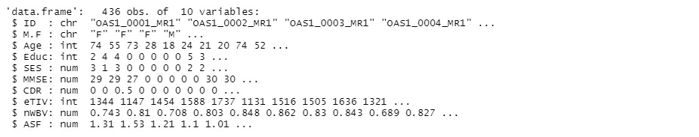
Image 3 Str Data

From Image 3, we can see that there are 436 obs of the dataset, and there are 12 variables. each variable will be adjusted to the needs and will go through a data split process.

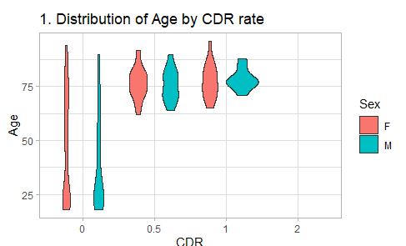
Image 4 Data Visualization by Age

Image 4 shows the first data visualization in this dataset. X absis in this output shows the Clinical Dementia Rate for each object, and Y absis shows the Age from each participants in this dataset While the legend section of image 4 shows the gender of each participant. from the results of data visualization based on age, it can be concluded that there is no significant relationship between age and gender of participants with the chance of developing dementia.

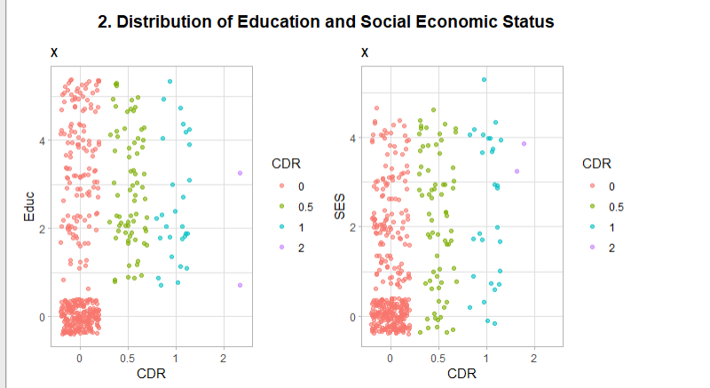

Image 5 Data Visualization by Education and Socio Economic Status

Image 5 shows the second data visualization in this dataset. X absis in the first and second output shows the Clinical Dementia Rate for each object. Meanwhile, Y absis in the first output shows the Education Year from each participant in this dataset. Y absis in the second output shows the Socio-Economic Status from scale one as the highest status into 5 as the lowest status While the legend section of Image 5 shows the CDR rate from each participant. from the results of data visualization based on education and SES can be concluded that there is no significant relationship between education + socioeconomic status of participants with the chance of developing dementia.

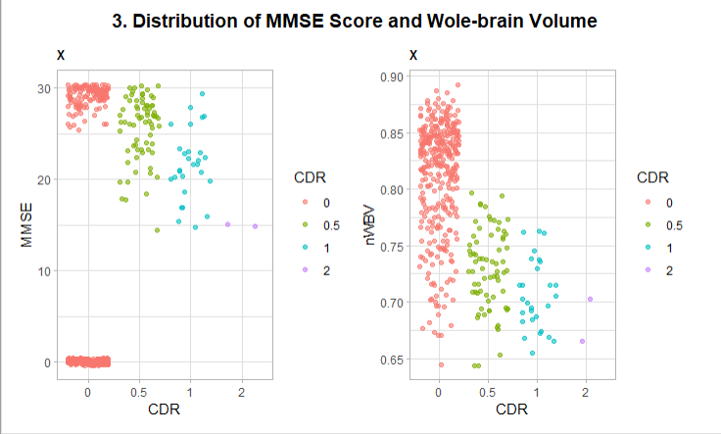

Image 6 Data Visualization by MMSE Score and WBV

Image 6 shows the second data visualization in this dataset. X absis in the first and second output shows the Clinical Dementia Rate for each object. Meanwhile, Y absis in the first output shows the MMSE Score from each participant in this dataset. Y absis in the second output shows the WBV value While the legend section of Image 6 shows the CDR rate from each participant. from the results of data visualization based on education and SES can be concluded that there is no significant relationship between MMSE and Wole-Brain Volume in Dementia Diagnosis.

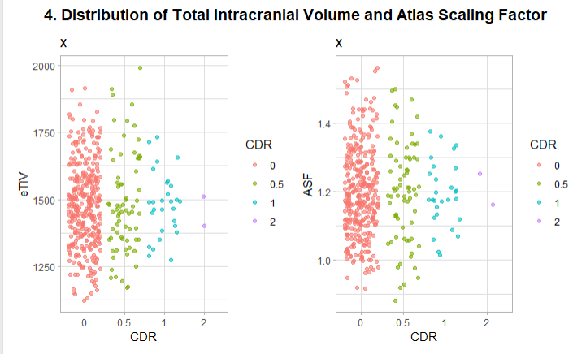

Image 7 Data Visualization by TIC Volume and Atlas Scaling Factor

Image 7 shows the second data visualization in this dataset. X absis in the first and second output shows the Clinical Dementia Rate for each object. Meanwhile, Y absis in the first output shows the eTiv from each participant in this dataset. Y absis in the second output shows the Atlas Scaling Factor While the legend section of Image 6 shows the CDR rate from each participant. from the results of data visualization based on education and SES can be concluded that there is no significant relationship between TIC Volume and Atlas Scaling Factor in Dementia Diagnosis.

Assesment and Testing

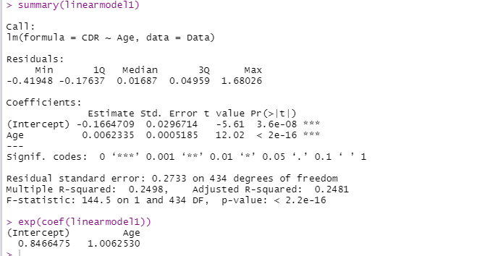

Image 8 Linear Model 1 Analyze

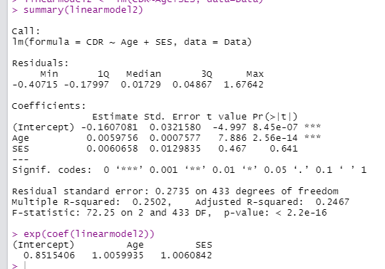

Image 9 Linear Model 2 Analyze

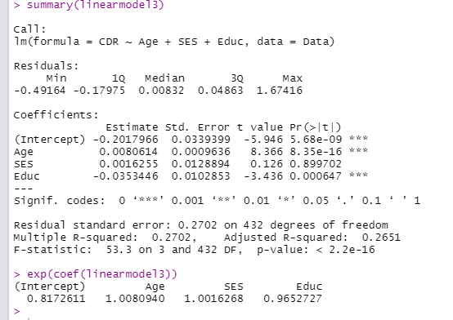

Image 10 Linear Model 3 Analyze

Before testing the algorithm, we have to make the linear model for each main variables. Each linear model have different variables that tested. Image 8 shows the Linear model 1 using the comparison between CDR and age variables as predictor variables, in the Image 9, shows the Linear model 2 using the comparison between CDR, Age, and SES as predictor variables and in the Image 10 shows the Linear model 3 using the comparison between CDR, Age, SES, and Educ as predictor variables.

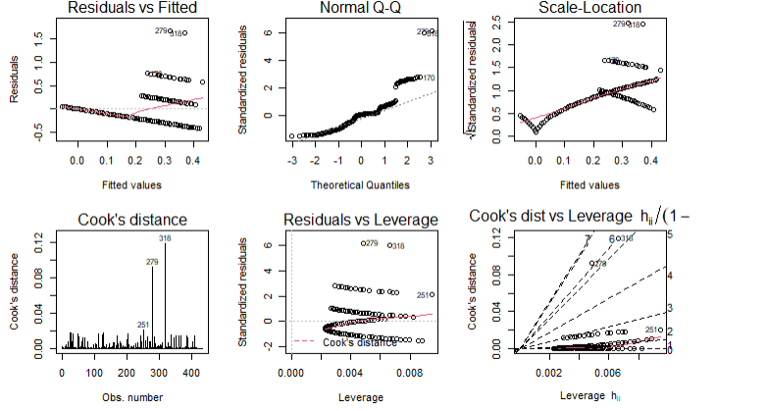

Image 11 Linear Model 1 Plot

Image 11 shows the Linear Model 2 Plot that contains several models such as Residuals vs Fitted Models, QQ plot, Scale Location plot, Cook’s distance plot, Residuals vs Leverage plot, and Cook’s dist vs Leverage plot.

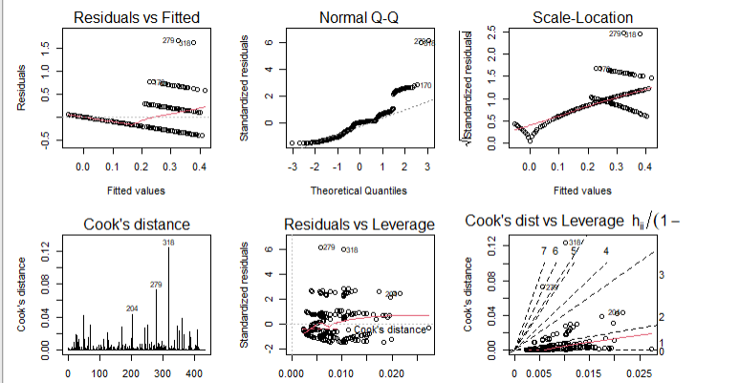

Image 12 Linear Model 2 Plot

Image 11 shows the Linear Model 2 Plot that contains several models such as Residuals vs Fitted Models, QQ plot, Scale Location plot, Cook’s distance plot, Residuals vs Leverage plot, and Cook’s dist vs Leverage plot.

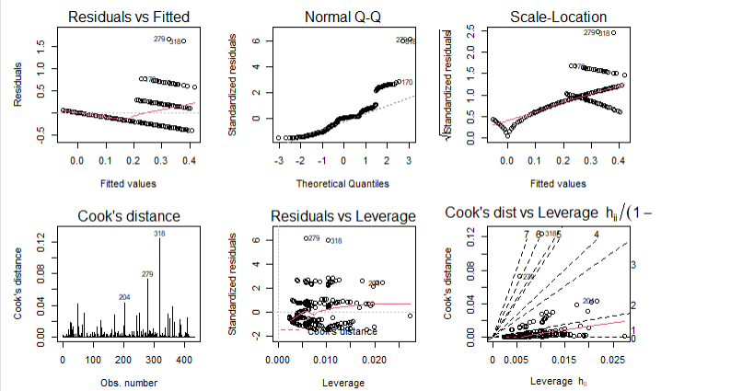

Image 13 Linear Model 3 Plot

Image 13 shows the Linear Model 3 Plot that contains several models such as Residuals vs Fitted Models, QQ plot, Scale Location plot, Cook’s distance plot, Residuals vs Leverage plot, and Cook’s dist vs Leverage plot.

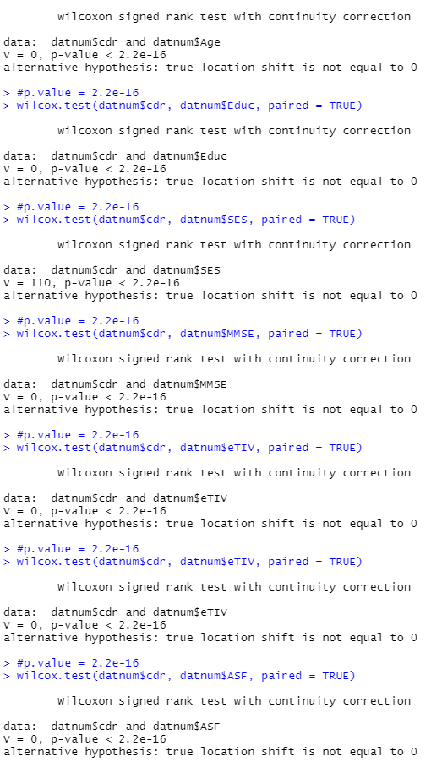

Image 14 Wilcoxom Test (DBSCAN)

Image 14 shows the Wilcoxon test in DBSCAN Algorithm and result for each numerical variabels. The result is the p-value that represents the strength of the relationship between the variables.
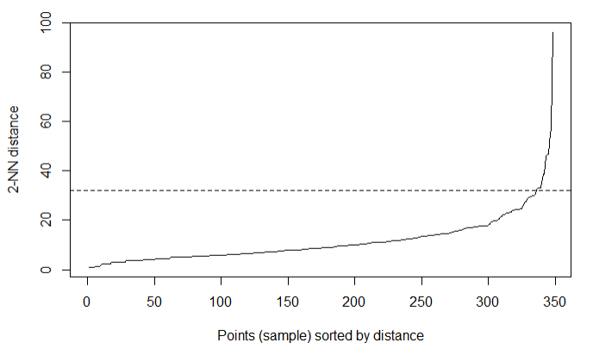

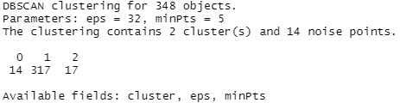

Image 15 Epsilon Test Visualize by Neighbor Distance Plot

Image 15 show the epsilon test visualize by neighbor distance plot and the result shows the present total objects are 348 with the epsilon parameter = 32 and minimum points that required are 5. The clustering also contains 2 cluters and followerd by 14 points that indetified as noise.

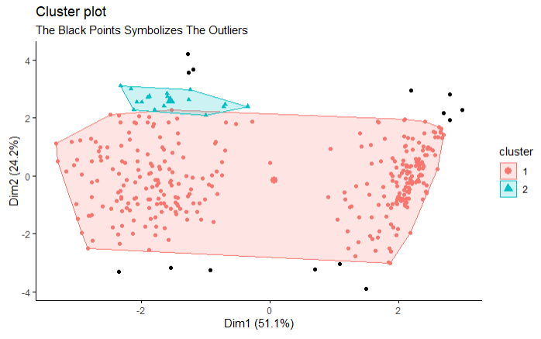

Image 16 Cluster Plot

Image 16 shows the cluster plot in dementia dataset using DBSCAN algorithm. The clusters were represented with 3 colors, green that describe the cluster 2 and red as the cluster 1 and black dots outside the cluster 1 and cluster 2 represent the noise. The value of cluster (1 and 2) represent the CDR rating from people that have been tested while 1 means mild dementia and 2 means that they have suffer dementia.

Implementation and Result

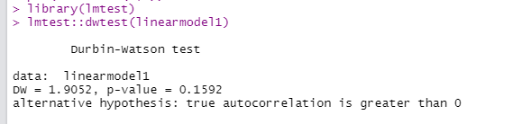
Image 17 Durbin Watson Test Linear Model 1

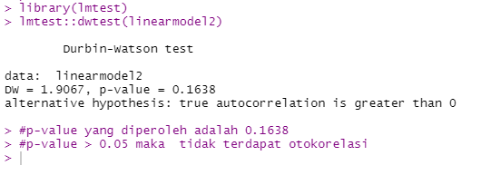
Image 18 Durbin Watson Test Linear Model 2

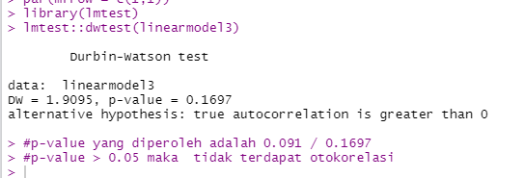

Image 19 Durbin Watson Test Linear Model

The first test that we gonna use is dublin watson test. we're gonna check if there is an autocorrelation in each model by seeing the p-value. if the null hyphotesis is rejected, we can conclude that the linear model is an autocorrelation.

Based on Image 17, 18 and 19, we can conclude that In linear model 1, we can see that the p-value is greater than 0.05, it means that the null hypothesis is accepted and there is no auto correlation in linear model 1. in linear model 2 and 3, they have the same result like linear model 1, which is the null hypothesis is reject and we can conclude that there is no auto correlation in all of these 3 linear models

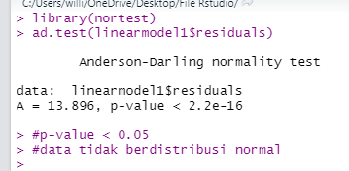

Image 20 Anderson-Darling Normality test on Linear Model 1

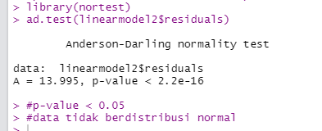

Image 21 Anderson-Darling Normality test on Linear Model 2

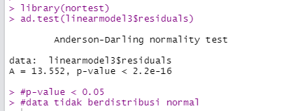

Image 22 Anderson-Darling Normality test on Linear Model 3

Image 20-22 shows the Anderson-Darling test on each linear model. AD test was performed to see if the residuals were normally distributed or not. if the p-balue are greater than 0.05, the linear model is normally distributed. As we can see from image 20-image 22, we can conclude that all of those three linear models p-value is smaller tha 0.05 so we can conclude that this linear model is not normally distributed.

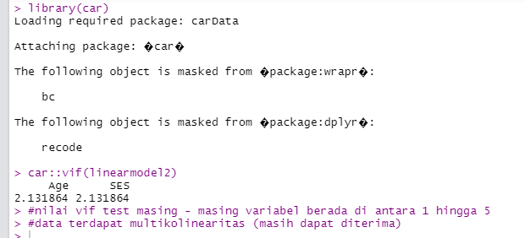

Image 23 Variance Inflation factiors test on Linear Model 2

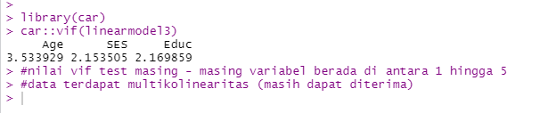
Image 24 Variance Inflation factiors test on Linear Model 3

Image 23 and 24 shows the Variance Inflation Factors test on each linear model.VIF is used to check wheter there is multicolinearity or not. we're not using the linear model 1 because it only use 1 predictor variables. In linear model 2, each of variables VIF test is between 1 and 5, which is indicating there is a moderate correlation between the predictor variables. its Acceptable but not good enough because we need the VIF values are greater than 5 to conclude that there is a strong correlation between the predictior variables. Same as model 3, each of variables VIF test is between 1 and 5, it means that there is a moderate correlation between the predictor values

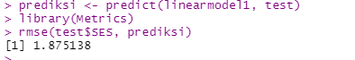

Image 25 RMSE Test on linear Model 1

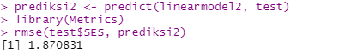

Image 26 RMSE Test on linear Model 2

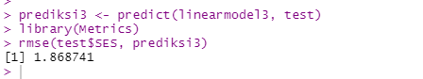

Image 27 RMSE Test on linear Model 2

Image 25-27 shows the RMSE test on each linear model. RMSE value is the difference between the actual value and the predicted value that shows the prediction error. The smaller the RMSE VALUE number, it means that the error rate is small to.From all of those 3 linear models, we can conclude that the linear model 3 is better than other model in predictive quality, because the RMSE is the smallest than the others (1.868741)

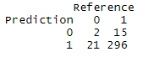

Image 28 DBSCAN Algorithm Prediction

Image 28 shows the prediction from DBSCAN Algorithm. Most of the prediction was on 1 CDR rate (296)

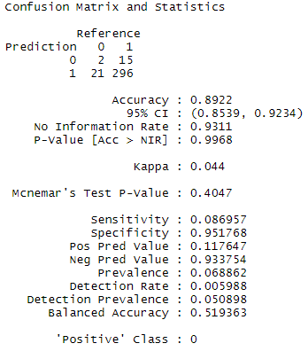
Image 29 DBSCAN Algorithm Confusion Matrix

From Image 29, We can see the results of implementing the two algorithms in the form of a confusion matrix generated by both. The results of the confusion matrix on DBSCAN algorithm show an accuracy rate of 89.22% and an error of 10.88%. The sensitivity level generated from this algorithm is 86%, and specificity is 95% for participants who do not have dementia.

Discussion
Numerical variables in this dementia dataset have an essential role in making predictions in this research. Both algorithms use the Clinical Dementia Rate variable as the main comparison, both in Linear Regression and DBSCAN algorithm. The results of this prediction must begin with data filtering and dividing the dataset into testing and training data. Both the results of the Linear Regression and DBSCAN algorithms produce an accuracy rate above 50%, proving that both models are valid to be used and implemented in real-life situations. The accuracy result shows that DBSCAN algorithm have the better accuracy prediction if compared to Linear Regression.

Conclusion

Conclusion
Dementia is a disease that requires extra attention from the closest party. Many sacrifices must be issued in the face of this disease, both financially and mentally. Patients with this disease require extra attention because it is related to the loss of a person's motor skills which is very inconvenient to interact with others. The Linear Regression and DBSCAN methods in this research proved to produce reasonably accurate prediction results, namely 1.868741 on the best linear model with RMSE Test and about 89% on the method. This study aims to help the public find out the main factors that can trigger dementia by making predictions according to specific variables in the dataset with various algorithmic methods, especially with DBSCAN Algorithm, which produces a higher level of accuracy.

Suggestion
In order to produce precise and accurate prediction results in predicting dementia values, of course, a more valid and relevant dataset is needed based on the times. And also does not rule out the emergence of new algorithms in data analysis that produce more accurate predictions about dementia in the future. In this study, the DBSCAN algorithm can be used as a method to predict dementia with reasonably accurate results.

Acknowledgements
I would like to express my gratitude to Ir. Raymond Sunardi Oetama, M.CIS as the lecturer in Information Systems Major, Faculty of Engineering and Informatics Universitas Multimedia Nusantara, for your consistent support and guidance through the material presented in Data Analysis class. I would also to thank group 3, who discussed and dissected the specified topic together despite using different algorithmic methods.

References

[1] | S. Cahill, “WHO's global action plan on the public health response to dementia: some challenges and opportunities,” Aging & Mental Health, Jan 2019.
[2] | N. B. P. G. S. Anupam Gupta, “Rehabilitation in Dementia,” Indian Journal of Psychological Medicine, August 2021.
[3] | L. M. M. G. M. A. Hernan Ramos, “Pharmacists’ Knowledge of Factors Associated with Dementia:The A-to-Z Dementia Knowledge List,” International Journal of Environmental Research and Public Health, September 2021.
[4] | A. C. Sombat Meungtaweepongsa, “Music Therapy in Dementia,” Asian Medical Journal and Alternative Medicine HRH Princess Chulabhorn College of Medical Science, Chulabhorn Royal Academy, Bangkok, Thailand, May 2021.
[5] | S. M. Valenzuela, “Dementia and Physical Therapy,” Web of Science™ Core Collection (BKCI), July 2021.
[6] | X. L. Tran, “A sequential piecewise linear regression model for data analysis developed with Visual C# .NET,” DTU Journal of Science and Technology, pp. 05(42) (2020) 1-6, 2020.
[7] | P. G. J. Y. Hanlin Zhang, “Machine Learning on Cloud with Blockchain: A Secure, Verifiable and Fair Approach to Outsource the Linear Regression for Data Analysi,” IEEE Transactions on Network Science and Engineering , p. :10.1109/TNSE.2021.3110101, 2021.
[8] | A. Essivi, “Regression Data Analysis of How Factors Influence Opportunities for Employment Creation in China,” Journal of Research in Business, Economics and Management , no. ISSN: 2395-2210 , pp. Volume 9, Issue 4, 2017.
[9] | A. H. Vincent Adam, “NON-LINEAR REGRESSION MODELS FOR BEHAVIORAL ANDNEURAL DATA ANALYS I,” CRM Centre for Mathematical Research, 2020.
[10] | M. R. A. C. Francesca Torti. Domenico Perrotta, “Assessing trimming methodologies for clustering linearregression dat,” Advances in Data Analysis and Classiﬁcation Journal, 2018.
[11] | I. C. Marta Mieczynska, “DBSCAN Algorithm for AIS data rescontruction,” 25 th International Conference on Knowledge-Based & Engineering Systems, 2021.
[12] | J. I. Zakir Hossain, “Develop a dynamic DBSCAN algorithm for solving initial parameter selection problem of the DBSCAN algorithm,” Indonesian Journal of Electrical Engineering and Computer Science , no. ISSN: 2502-4752, p. pp. 1602~1610, September 2021.
[13] | P. D. Go Sato, “A Novel Recursive Non-Parametric DBSCAN Algorithm for 3D Data Analysis with an Application in Rockfall Detection,” Journal of Disaster Research 16(4):579-587, no. DOI:10.20965/jdr.2021.p0579, 2021.

